🛠 Setup Guide: Daily AWS Cost Alert Using Cost Explorer API and SNS

1. Prerequisites • AWS account with permissions to create IAM, Lambda, SNS, and EventBridge resources. • Python 3.12+ installed locally (optional, if you want to test code before uploading). • AWS CLI configured (aws configure) if you want to test outside the console.

2. Write the Lambda Function The Lambda function code queries AWS Cost Explorer for month-to-date spend and publishes an alert if it exceeds a threshold.

https://github.com/shaikhniraj/AWSCostAlertUsingCostExplorerAPIandSNS

3. Create IAM Role (Console)
- Go to IAM → Roles → Create Role.
- Choose Lambda as trusted entity.
- Attach inline policy with permissions:
  - ce:GetCostAndUsage
  - sns:Publish (scoped to your topic ARN)
  - CloudWatch Logs permissions (logs:CreateLogGroup, logs:CreateLogStream, logs:PutLogEvents)
- Save role as LambdaCostAlertRole.
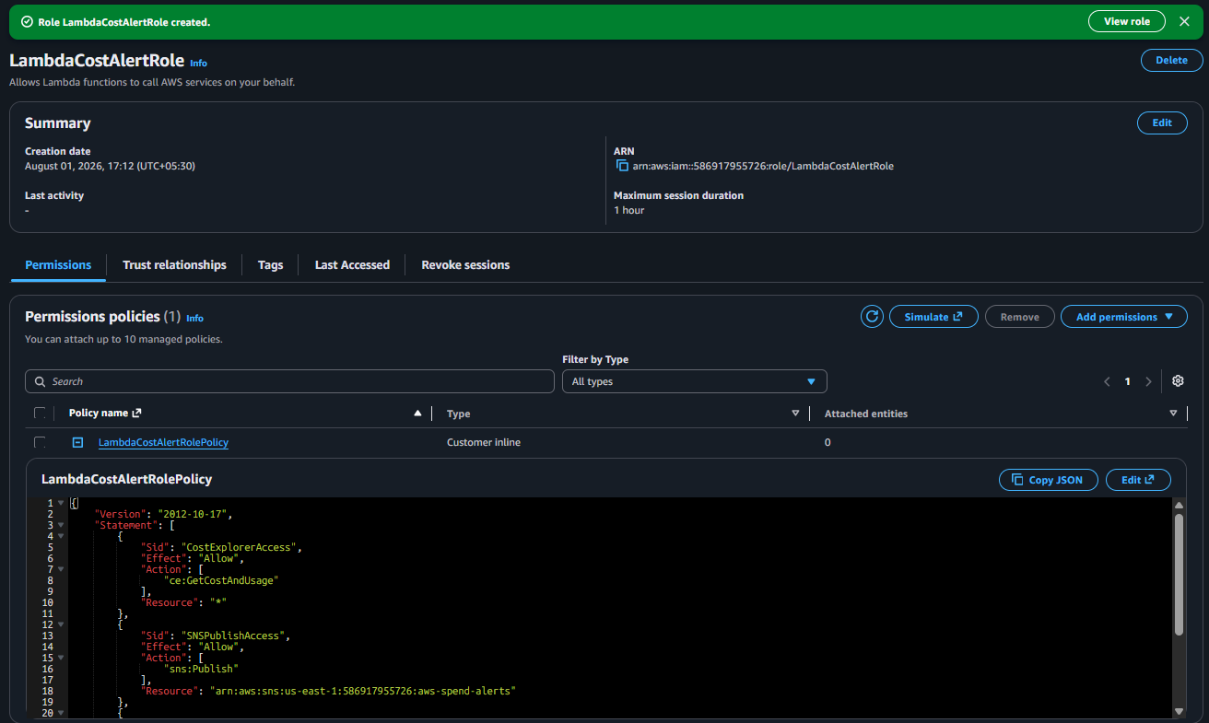
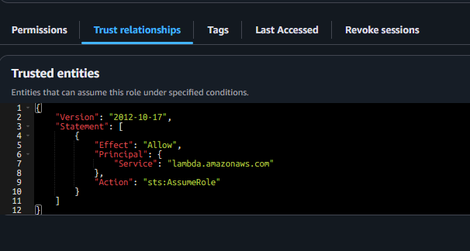

4. Create SNS Topic
- Go to SNS → Topics → Create Topic.
- Name: aws-spend-alerts.
- Create a subscription with your email.
- Confirm the subscription via the email AWS sends.
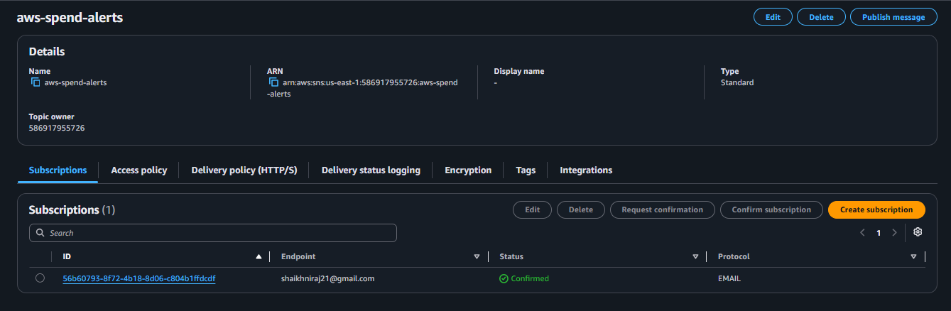

5. Create Lambda Function (Console)
- Go to Lambda → Create Function.
- Runtime: Python 3.12.
- Upload your code or paste it into the inline editor.
- Assign IAM role LambdaCostAlertRole.
- Add environment variables:
  - SNS_TOPIC_ARN = ARN of your SNS topic
  - THRESHOLD = e.g., 50
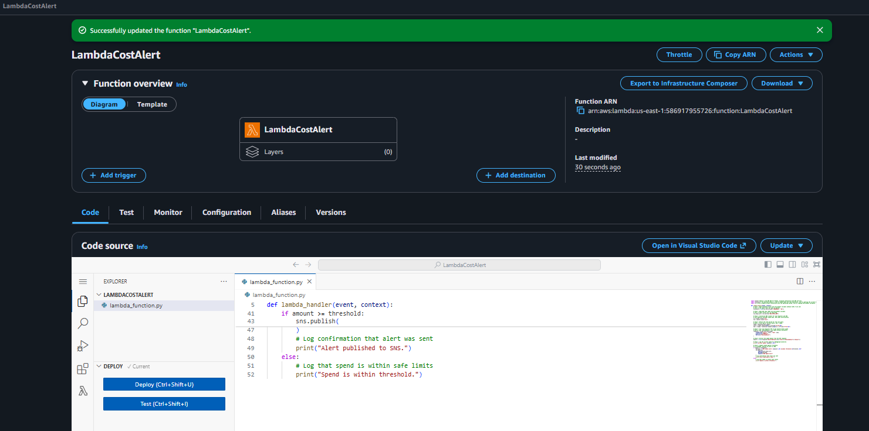

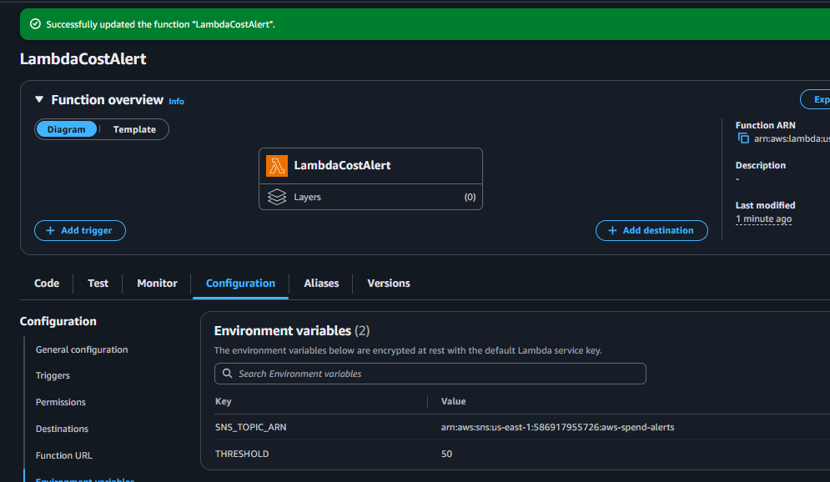

6. Create EventBridge Rule
- Go to Amazon EventBridge → Rules → Create Rule.
- Name: DailyCostAlert.
- Schedule expression: cron(0 6 * * ? *) → runs daily at 6 AM UTC.
- Target: your Lambda function.

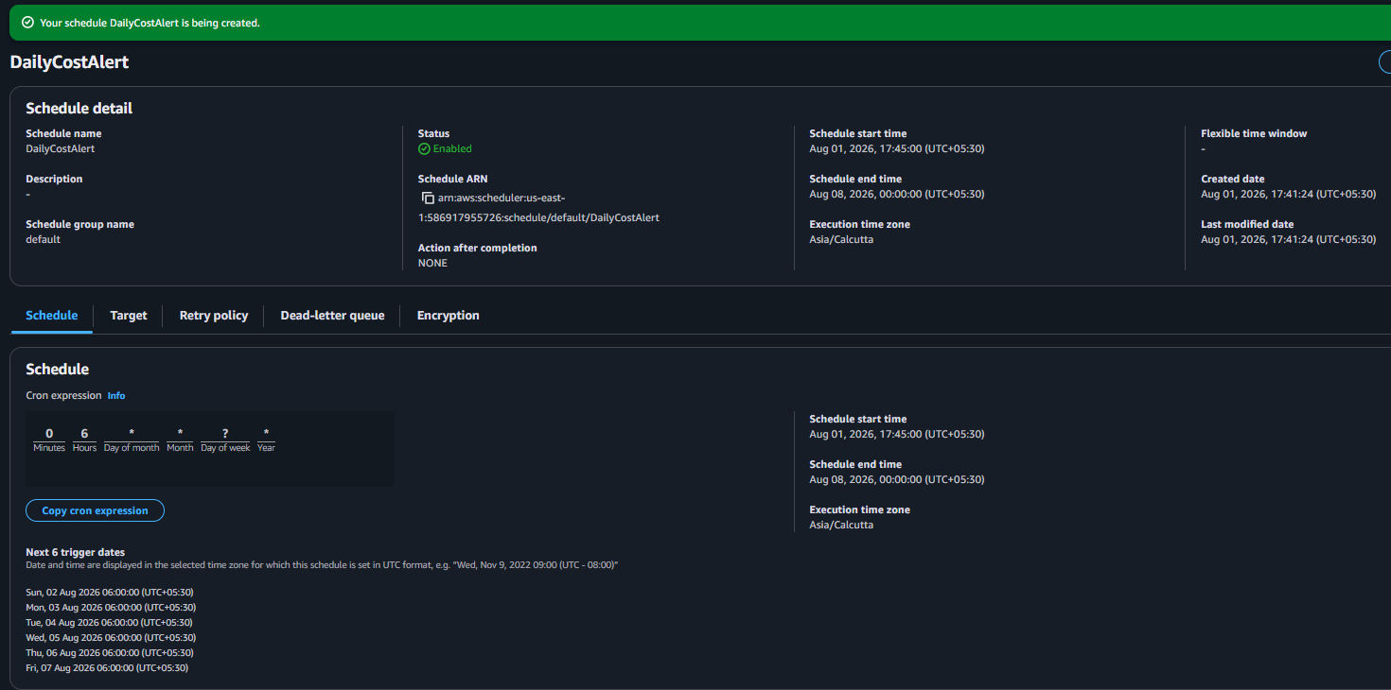
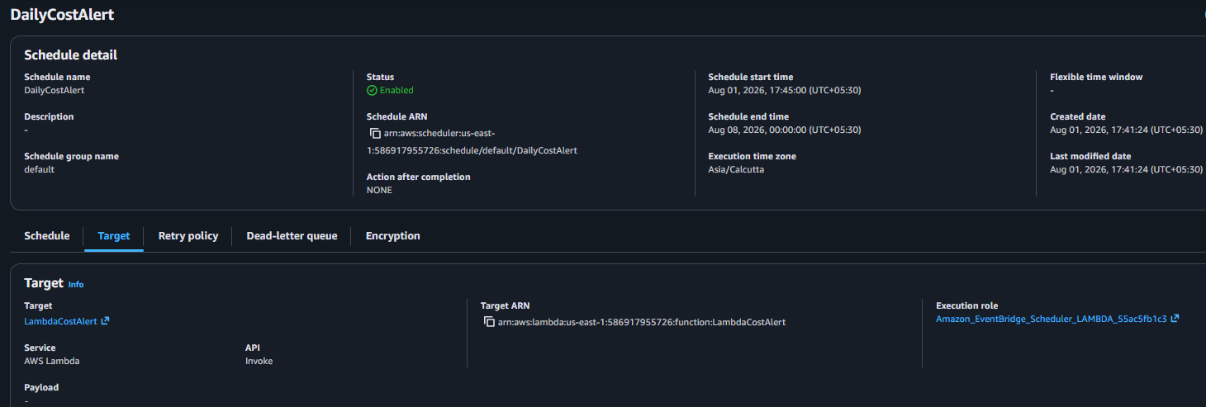

- Test the Lambda
• Set THRESHOLD=0.01 in environment variables. (0.01 is not working so set it to zero for testing purpose)
• Trigger manually → should force an SNS email alert.
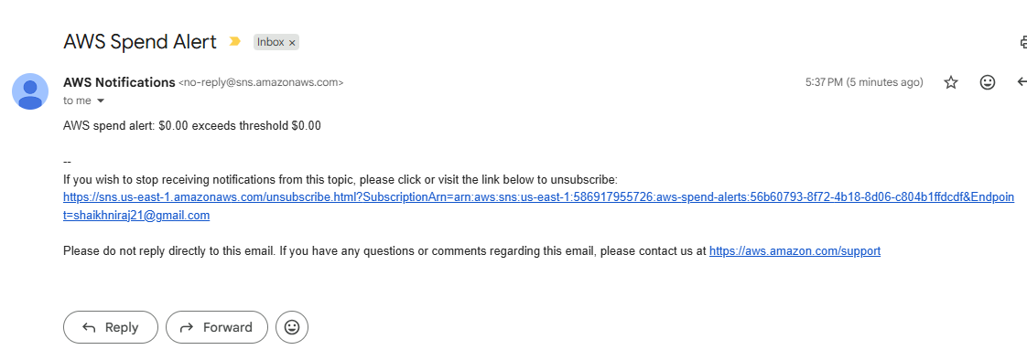
• Check CloudWatch Logs for confirmation messages.
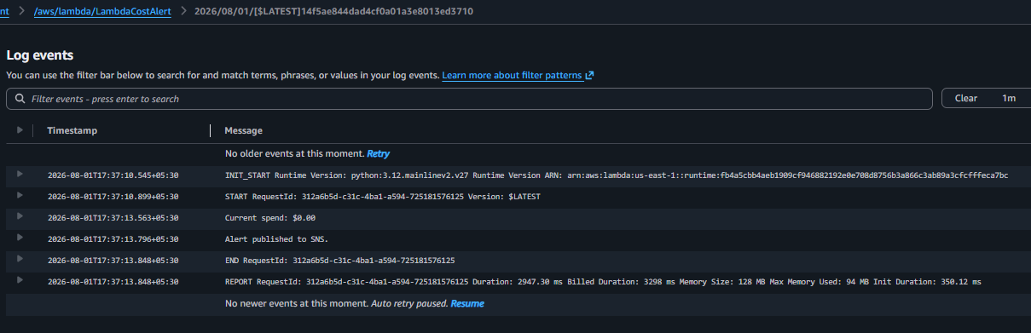

📌 Discussion Point • AWS Budgets: Managed service for spend alerts, integrates with email/SNS, easy setup. • Custom Lambda + EventBridge is useful when you need:
- Per-service breakdowns (EC2 vs S3).
- Slack/Teams delivery instead of email.
- Custom anomaly detection logic.
- Integration with internal dashboards or ticketing systems.

